Project Plan Recap
Connor Allison & Dino Rocca
14/01/26
Task 1: Workflow chart
- Create a workflow style chart outlining Research Method
  - Probe search on SPECTRONAUT: PTMs identified, distribution of differentially modified proteins etc
  - Variable search of 3 PTMs: Compare against probe data, is it similar, do we get more in-depth coverage,
  - Analysis of high confident sites on inflammasome components (novel, reproducible to other data, mapping on AlphaFold)
Task 2: Probe Search (Take Images from Spectronaut or create graphs via Rstuio)
- Run Spectronaut Probe Search on THP1 PMA Data
- Identified PTMS
  - Number of precursors identified
  - Number of proteins identified via PTM etc
- Volcanos
  - Easier if you split your analysis into two groups
    - Unstim, LPS, Nigericin, LPS + Nigericin
    - Unstim, P3C4, Nigericin, P3C4 + Nigericin
  - 1st step genereate plain volcanos per activation stage
    - LPS vs Unstim
    - LPS vs LPS + Nigericin
    - LPS vs Nigericin
    - Nigericin vs Unstim
    - Nigericin vs LPS + Nigericin
    - LPS + Nigericin vs Unstim
    - P3C4 vs Unstim
    - P3C4 vs P3C4 + Nigericin
    - Same patternas above

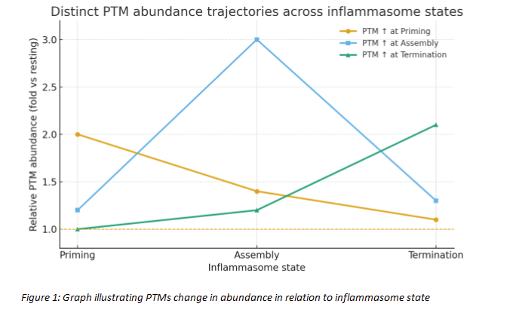
  - E.g Figure
    - Probe Search PTM Modifications across LPS + Nigericin VS LPS
      - Split into 6 sections, 1 A raw volcano, b gglygly, c phosphor, d acetyl etc
  - Aim here is to see whether you can identify proteins that are being differentially modified or do certain PTMS occur at a particular stage of activation
  - Create volcanos and then choose PTMS of interest and plot those proteins to see patterns
- Inflammasome proteins
  - It might be interesting to create a table looking at inflammasome components and whether they detected a PTM (NLRP3, PYCARD, ASC (PYCARD), IL1B, IL18 and a few others)
  - Columns equal all inflammasome proteins, rows all the PTMS, and insert the number of how many sites of that PTM was detected (no
  - To do this you will have to create a protein of interest excel sheet and compare this to the candidate data.
- All the above will be used to help dictate the closed search
- We will work up to having some data and story and then will sit down with Ben, discuss the current results and method and get his feedback
Task 3 & 4: TBC

